Assessing Participants: Agenda Assessment

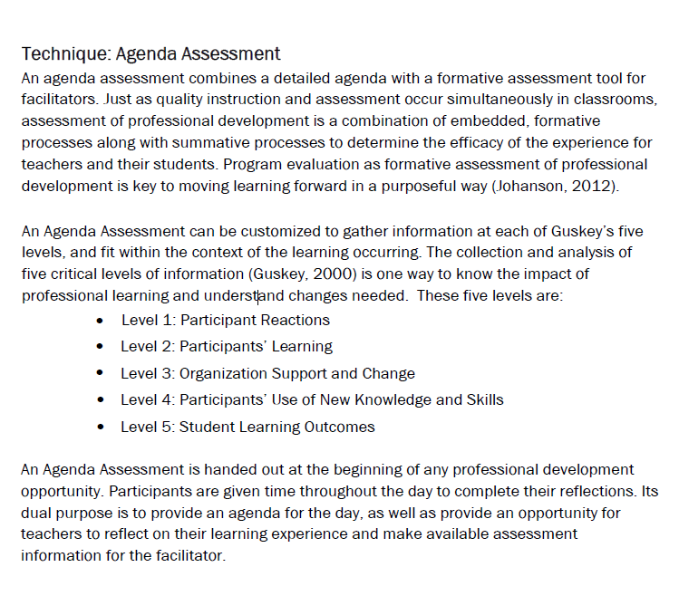
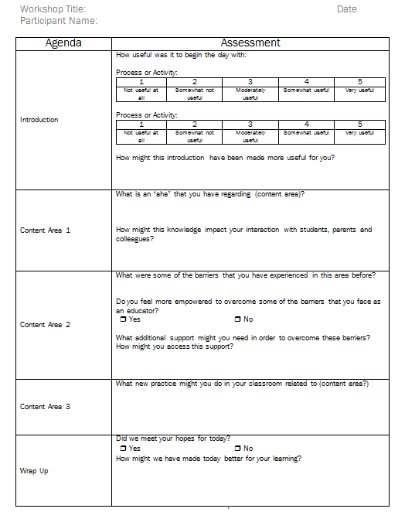
Participant Reaction
Intent to Implement
Participant Learning
Barriers to Implementation
Participant Reaction

