Multiplication and Division

Single Digit Multiplication Facts
Multiplication facts should be introduced and mastered by relating to existing knowledge. If students are stuck in a ‘counting’ stage – either by ones or skip-counting to know their single-digit multiplication facts, it is important that they understand strategies beyond counting before they practice. Counting is a dangerous stage for students, as they can get stuck in this inefficient and often inaccurate stage. Students should not move to multi-digit multiplication before they understand multiplication strategies for single-digit multiplication.
- It is important that students understand the commutative property 2 x 4 = 8 and 4 x 2 = 8.
- 2 x 4 should be related to the addition fact 4 + 4 = 8, or double 4.
- Using a multiplication table as a visual structure is helpful to see patterns in multiplication facts.

Mental Strategies Continuum

- Same as (1 facts)
- Doubles. (2 facts)
- Doubles and 1 more (3 facts)
- Double Doubles (4 facts)
- Tens and fives (10, 5 facts)
- Relating to tens (9 facts)
- Remaining facts (6, 7, 8 facts)

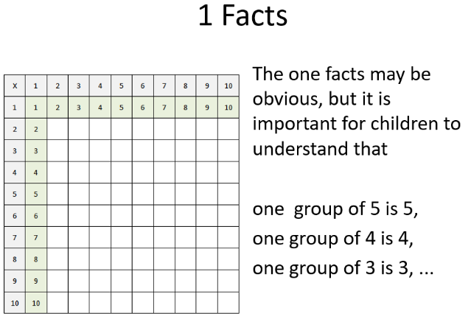 | 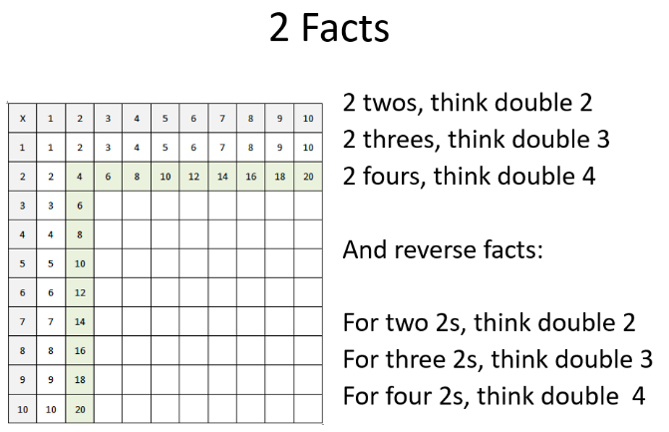
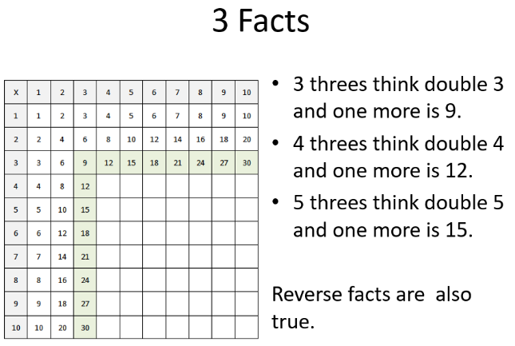 | 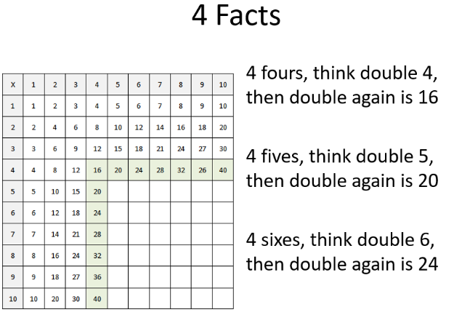

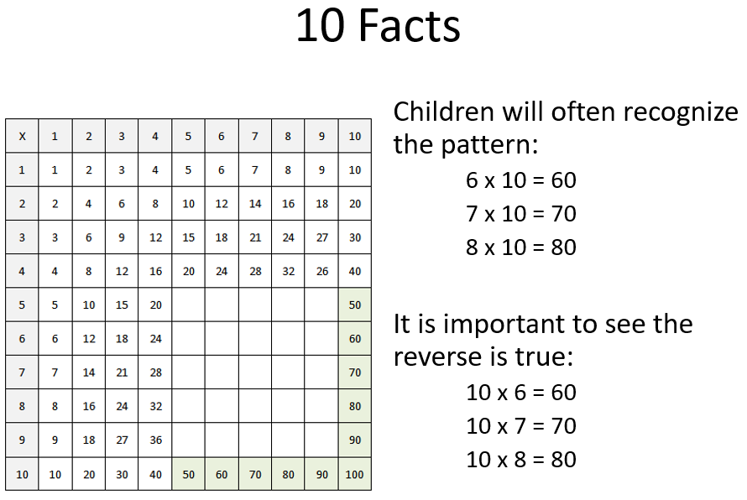 | 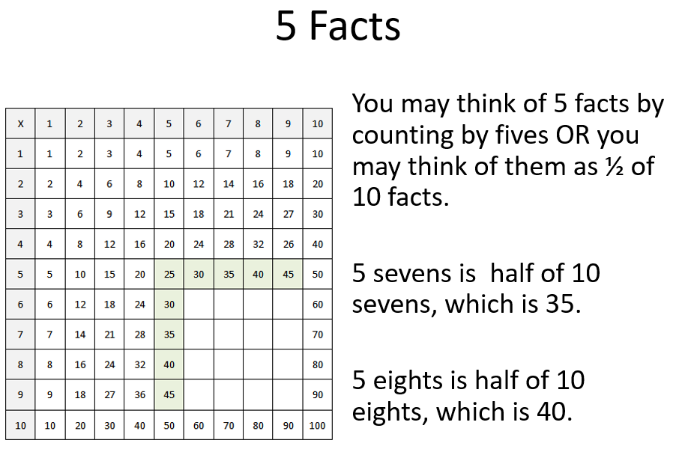
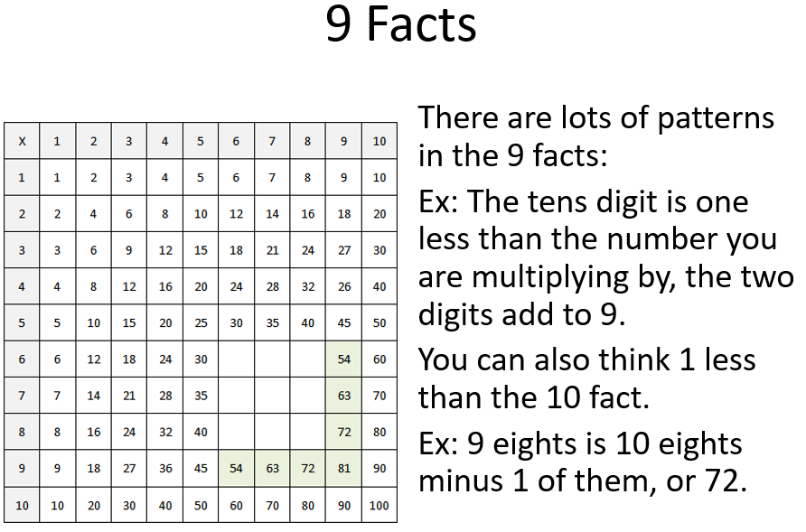 | 