The Number Line Routine (K-5 Math Teaching Resources LLC, n.d.)
- To visualize the magnitude of numbers and emphasize partitioning.
Determine whether curriculum is requiring locating a number on a number line or showing an operation.
Place the number and explain.  Pose the problem.  Monitor responses.  Select sharing order and write out these examples. | Show 23 on a number line.  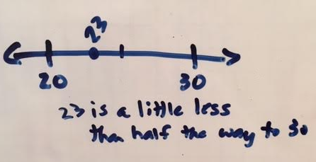
Partition number, introduce to “one less” or “one more” ideas.  Pose the problem.  Monitor responses.  Select sharing order and write out these examples. | How can we go from 0 to 79 in the smallest number of jumps using 10s and 1s?  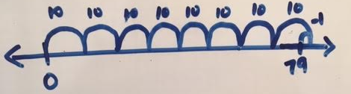
Showing operations: Addition  Pose the problem.  Monitor responses.  Select sharing order and write out these examples. | How might we solve 37 + 48 using an open number line?  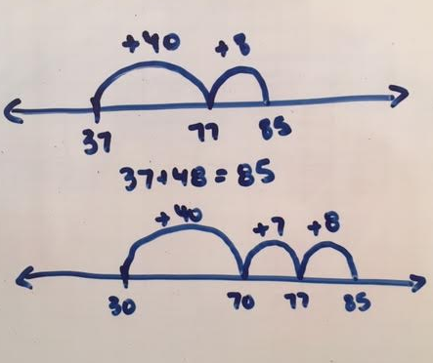
Showing operations: Multiplication  Pose the problem.  Monitor responses.  Select sharing order and write out these examples. | If a box holds 25 apples, how many boxes can be filled with 342 apples?  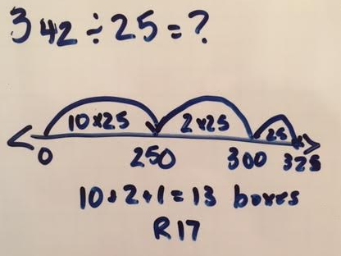
Repeat – Pose: What is another way you can show this number (or operation)?

