Planning Sequence: Differentiating Instruction

Content

Process
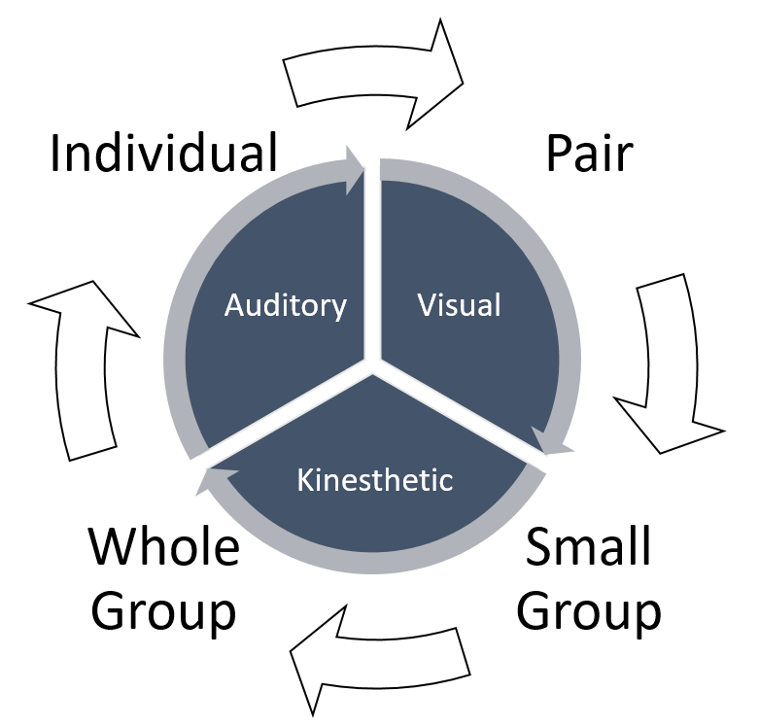
Idea: Offer a choice board for students to explore new learning in the area of their preference.
Idea: Offer a variety of strategies throughout a unit of study in different modalities. Example: Daily 5.

Product
How are students going to demonstrate their understanding of the outcome?
- artefacts should all be the same DEPTH of knowledge that matches the curricular outcome, not harder and easier.
- Choice can be given as a menu or open-ended.

